# Wireless Motion Detector User Manul

## Specifications:

Trigger Conditions: Anti-disassembly switch, low voltage, sensor

Infrared Sensor: Dual passive infrared pyroelectric sensor

Detection Range: Wide-angle lens Max. 12m

Detection Angle: 100° Wide angle lens

Alarm Interval: 10s/1min/5min/10min

Working Voltage: DC3V

Working Current: ≦30MA

Static Current: ≦25uA

Battery Life: 2 years

Working Temperature:-10℃ **~ +**50℃

Relative Humidity: ≦90%

Indicator: infrared trigger, low voltage, charging state

RF Frequency: 433.92MHZ

Frequency Modulation Mode: ASK

Transmit power: 10db

Wireless distance: ≦120m (open area)

Dimensions: 107*57.4*37mm

## 2.Detection Range Diagram

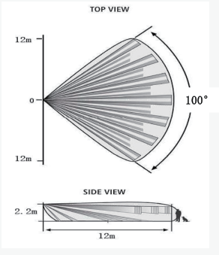

Note: The direction and Angle of the equipment can be adjusted according to the actual situation during installation to achieve the best effect.

## 3.Product Structure Diagram

## 1713496570442

1.Antenna

2.Test button

3.LED indicator

4.Sensing head

5.Battery

6.Dip switch

## Working Description

This detector is designed using the principle of the human infrared spectrum and Doppler motion detection technology. With a special filter lens and advanced signal analysis technology, it can be used in a variety of places such as banks, warehouses, office buildings, homes, trucks, ships, garages, and more.

(1) Indicator Z2 (Red) :

When the first power on, the red and green lights up for one second at the same time, and then start to alternately flash into self-check mode. Red and green lights off at most 30S exit self-test.

The red light is on when the infrared is triggered and data is sent to the host (Can be enabled by the toggle switch).

1. Indicator Z1 (Green) :

When the battery is low, it blinks with a buzzer, about 1 minute/time.(Can be enabled by toggle the switch)

(3) Infrared alarm: when someone enters the detection area, it will trigger the infrared alarm and send alarm data to the host.

Note: The time interval for each alarm trigger is fixed, and an alarm can be generated after each set time. If there is a large personnel flow, it is recommended to set the alarm interval as large as possible to reduce power consumption. (Can be enabled by the switch).

(4)Anti-demolition alarm: After the anti-demolition button is pressed for more than 10 seconds, it will trigger the alarm.

(5) Low battery alarm: When the battery is too low, it will send a "low voltage alarm" to the host, and it will beep and flash green every 1 minute.

(6) Test alarm: After pressing the test button, the infrared will issue alarm information.

(7) Dip switch setting function.

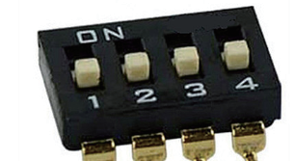

**a. Set the interval for each alarm**

|  |  |  |  |  |
| --- | --- | --- | --- | --- |
| Control function | Pin number | Number 1 | Number 2 | Instruction |
| Set the interval at which each alarm is allowed | Combine number 1 and 2 to select four times | Switch to the ON side | Switch to the ON side | 10 minutes/time |
| Switch to the Number side | Switch to the ON side | 5 minutes/time |
| Switch to the ON side | Switch to the Number side | 10 seconds/time |
| Switch to the Number side | Switch to the Number side | 1 minute/time |

**b. Set the switch of low voltage alarm and LED**

|  |  |  |  |  |
| --- | --- | --- | --- | --- |
| Control function | Pin number | Switch to the ON side | Switch to the Number side | Instruction |
| Low voltage LED | Number 3 | No green signal at low pressure | Low voltage interval 1 minute green prompt | **/** |
| Alarm LED | Number 4 | No red light at alarm | C | **/** |

## 5.Installation Precautions

(1) This product is wall-mounted installation, it is recommended to install the height of 2-2.5m from the ground, otherwise it may affect the distance and sensitivity.

(2) Avoid installation in the case of direct light.

(3) Avoid installation in high temperature or water steam and other easy to cause condensation.

(4) Avoid installation directly facing the air conditioner or heat source.

(5) Avoid installation in the case of easy vibration or shaking.

(6) Avoid installation in places where there are screens or curtains that block detection areas.

(7) Avoid use in occasions where the temperature and humidity change too much, such as ventilated aisles or rooms.

(8) Do not touch the surface of the sensor during installation, so as not to affect the detection sensitivity.

(9) When installed in a large personnel flow situation, please set the alarm interval as large as possible to reduce power consumption.

(10) This product is used indoors, do not install outdoors.